An Internship Report

On

**iOS MOBILE APP DEVELOPMENT**

Submitted to **Walchand College of Engineering, Sangli** for the partial fulfillment of Bachelor of Engineering (UG) Degree in **Computer Science &Engineering**

Submitted By

**SURAJ SHANTINATH UPADHYE 245200001**

**Course: B.Tech (CSE) - Second Year**

**Internship Duration: 16-12-2024 to 10-01-2025**

Guided By

**Miss.** **A.S. Pawar**



**Department of Computer Science and Engineering**

**Walchand College of Engineering, Sangli**

Academic Year 2024 – 25 (Sem-III)

**Acknowledgement**

I am truly grateful to **Walchand College of Engineering, Sangli,** and the **Department of Computer Science and Engineering** for granting me the opportunity to participate in the iOS Mobile App Development Internship. This experience has been immensely valuable, enabling me to develop practical skills in iOS app development using Swift, Xcode, and UIKit.

I sincerely appreciate the support of Dr. M. A. Shah (Head of the CSE Department) and Dr. U. A. Dabade (I/C Director, WCE Sangli) for facilitating this internship. I also extend my gratitude to the internship coordinators, Mr. N. V. Marathe and Mr. N. V. Patel, for their guidance and seamless coordination of the training sessions.

A special thank you goes to the Apple Certified Trainers—Mr. Siddharaj D. Pujari, Ms. Nandini L. Mudegol, Ms. Aprupa S. Pawar, and Mrs. Swapnali A. Aitwade—for their dedicated teaching, valuable mentorship, and constant encouragement. Their expertise has played a key role in strengthening my understanding of mobile app development.

I would also like to acknowledge my fellow interns for their collaboration, insightful discussions, and shared learning experiences. The interactive and hands-on approach of this internship has significantly contributed to my professional and personal growth.

Lastly, I am grateful to my family and friends for their continuous encouragement and motivation throughout this journey. This internship has greatly enhanced my technical proficiency and has prepared me for future opportunities in mobile application development.

**Certificate:**

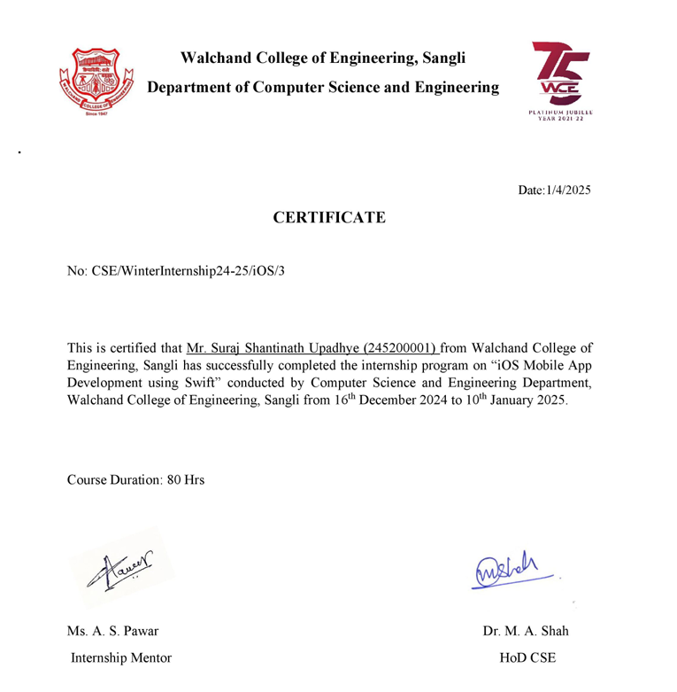

**Table of Content:**

1. Abstract
2. Introduction
3. About the Organization
4. Internship Work Description
5. Tools and Technologies Used
6. Learning Outcomes
7. Challenges Faced
8. Conclusion
9. References
10. Appendices (if any)
11. **Abstract**

The **iOS Mobile App Development Internship** at **Walchand College of Engineering, Sangli**, is a well-structured program designed to equip students with extensive knowledge and practical experience in iOS application development. Conducted under the **Apple Authorized Training Center for Education (AATCe)**, this internship provides industry-standard training led by Apple Certified Trainers.

The primary goal of this internship is to build a strong foundation in **iOS development**, ensuring participants gain expertise in **Swift programming, Xcode, and UIKit**. Emphasizing an application-based approach, the program enables students to create real-world mobile applications. The training is structured in a **hybrid format**, with **online sessions in December 2024** and **offline practical training beginning in January 2025**.

Throughout the internship, students engage in **interactive lectures, hands-on coding exercises, and project-based learning**, allowing them to apply theoretical concepts to real applications. The offline sessions provide access to the **departmental lab**, where students receive personalized mentorship from experienced trainers.

Upon completion, participants receive an **AATCe certification**, validating their expertise in iOS development. The internship also enhances their portfolios with functional iOS applications, improving their employability in the **tech industry**. Additionally, this program fosters **networking opportunities** with industry professionals and peers, encouraging collaborative learning and career growth.

1. **Introduction**

The **iOS Mobile App Development Internship** at **Walchand College of Engineering, Sangli**, provided an excellent opportunity to gain practical experience in iOS application development. Organized under the **Apple Authorized Training Center for Education (AATCe)**, the program focused on industry-relevant skills such as Swift programming, Xcode, and UIKit. The internship followed a **hybrid format**, with **online training in December 2024** and **offline practical sessions in January 2025**, ensuring a comprehensive learning experience.

**Objective of the Internship**

The core objective of this internship was to offer students a hands-on approach to iOS development, improving their programming proficiency and exposure to modern development tools. It aimed to enable participants to design and develop fully functional mobile applications while adhering to industry best practices and real-world development methodologies.

**Importance of the Internship**

This internship was highly relevant to my computer science and software development coursework, as it strengthened my understanding of object-oriented programming, UI/UX design, and mobile app frameworks. Additionally, it provided a solid foundation for future career opportunities in mobile development by offering hands-on experience with industry-standard tools. Earning an AATCe certification further boosts my professional credentials, increasing my competitiveness in the job market.

1. **About the Organization**

The iOS Mobile App Development Internship was conducted at Walchand College of Engineering (WCE), Sangli, a distinguished institution recognized for its excellence in technical education and research. This program was organized under the Apple Authorized Training Center for Education (AATCe), ensuring participants received industry-standard training and certification.

**Core Business Areas and Services**

Walchand College of Engineering (WCE) is a premier institution offering undergraduate and postgraduate programs across various engineering disciplines. The Department of Computer Science and Engineering (CSE) actively contributes to academic learning, research, and industry collaborations, ensuring students gain technical expertise and practical exposure.

The **iOS Mobile App Development Internship** is one of the many specialized training programs offered by WCE, bridging the gap between **academic learning and industry demands**. This program provides **hands-on experience in Swift programming, Xcode, and iOS app development**, under the mentorship of **Apple Certified Trainers**.

* **Organizational Structure**

The internship was guided by experienced **Apple Certified Trainers**, who played a vital role in delivering high-quality training. The **mentors and trainers** included:

1. **Mr. Siddharaj D. Pujari** (Apple Certified Trainer)
2. **Ms. Nandini L. Mudegol** (Apple Certified Trainer)
3. **Ms. Aprupa S. Pawar** (Apple Certified Trainer)
4. **Mrs. Swapnali A. Aitwade** (Apple Certified Trainer)

Additionally, the program was coordinated and supervised by:

* **Dr. M. A. Shah** – Head of the CSE Department, WCE Sangli
* **Mr. N.V. Marathe** – CCE Coordinator
* **Mr. N.V. Patel** – WCE Internship Coordinator
* **Dr. U. A. Dabade** – I/C Director, WCE Sangli

This structured approach ensured a **well-organized learning experience** with access to **highly qualified mentors** and a **collaborative environment**.

1. **Internship Work Description**

**Project Title: Simple Calculator App with History**

**Role and Responsibilities**

During the internship, my primary task was to develop a **calculator application with history functionality** using **Swift and UIKit** in **Xcode**. My responsibilities included:

* **Designing the UI**: Creating an intuitive calculator layout with buttons for digits and operations.
* **Implementing Arithmetic Operations**: Handling **addition, subtraction, multiplication, and division** with real-time calculations.
* **File Handling for History**: Storing calculations in a history file and retrieving past results for display.
* **Developing Multiple Views**: Implementing separate views for **calculator operations, result display, and history management**.
* **Clearing History**: Adding an option to delete stored calculations.
* **Debugging and Testing**: Ensuring smooth performance and fixing UI/logic issues.

**Process & Workflow**

1. **Understanding Swift & Xcode**
   * Set up **Xcode 13** and explored Swift basics.
   * Learned about **UIKit and Storyboard-based UI design**.
2. **Building the Calculator View**
   * Designed a **standard calculator interface** with buttons and a display label.
   * Implemented **button click handling** to perform basic calculations.
3. **Implementing Calculation Logic**
   * Used **Swift functions and event handling** to process user inputs.
   * Applied **error handling** for division by zero and invalid operations.
4. **Adding History Feature with File Handling**
   * Implemented **file handling in Swift** to store calculations persistently.
   * Used **appending mode** to add new calculations to the file.
   * Created a **History View** to display past calculations.
5. **Developing Clear History Functionality**
   * Provided a **"Clear History"** button to delete saved calculations.
6. **Testing and Debugging**
   * Used **Xcode’s iOS simulator** for testing.
   * Fixed UI layout issues and ensured calculations were stored correctly.
7. **Tools and Technologies Used**

During my iOS development internship, I worked with various tools, software, and frameworks that were essential for designing and implementing iOS applications. Below is a breakdown of the technologies used in the **Simple Calculator App with History** project:

#### ****Programming Language****

* **Swift** – The primary programming language used for iOS development. I applied concepts such as **functions, optionals, closures, enumerations, and object-oriented programming (OOP)** to implement the calculator's logic efficiently.

#### ****Development Environment & Tools****

* **Xcode** – Apple’s **Integrated Development Environment (IDE)** for developing iOS applications. It provided tools for **coding, UI design, debugging, and testing** the app.
* **Interface Builder** – Used to **design the UI visually** using Storyboards and connect UI elements to Swift code via **IBOutlet and IBAction**.
* **iOS Simulator** – Enabled testing and debugging of the app without requiring a physical iPhone.

#### ****Frameworks & Libraries****

* **UIKit** – Used for handling UI elements such as **buttons, labels, navigation controllers, and table views**.
* **Auto Layout** – Ensured a **responsive UI design**, allowing the calculator to adapt to different screen sizes and orientations.
* **FileManager** – Used to **store and retrieve calculation history** in a structured format within a local file.

#### ****Other Technologies****

* **Navigation Controller & Segues** – Implemented for **smooth transitions** between the Calculator View, History View, and Clear History View.
* **Stack View** – Used to organize **UI components in a flexible and scalable manner**.
* **Storyboard Segue** – Enabled seamless **data transfer** between different View Controllers, such as displaying past calculations in the History View.

By leveraging these tools and technologies, the **Simple Calculator App with History** was developed with a structured approach, ensuring **smooth user interaction, efficient data management, and a seamless navigation experience**.

1. **Challenges Faced**

During my internship, I encountered several challenges while developing the **Simple Calculator App with History**. Below are some key challenges and the solutions I implemented to overcome them:

1. **Handling Swift’s Optionals and Safe Unwrapping**
   * **Challenge:** Understanding **optionals** in Swift was initially confusing, and using force unwrapping (!) led to occasional runtime crashes.
   * **Solution:** I practiced **safe unwrapping** using if let and guard let, ensuring that values were safely extracted before use, reducing the chances of unexpected crashes.
2. **Implementing Auto Layout for a Responsive UI**
   * **Challenge:** Designing a **calculator UI** that adjusted seamlessly across different screen sizes was difficult, as constraints often conflicted.
   * **Solution:** I used **Stack Views** and Auto Layout to **dynamically position buttons and labels**, ensuring the UI remained consistent across different devices and orientations.
3. **Managing Navigation Between Screens Using Segues**
   * **Challenge:** Passing data between the **Calculator View, History View, and Clear History View** was tricky, as the data didn’t always update properly.
   * **Solution:** I implemented **prepare (for: sender:)** to **pass calculation results and history** between view controllers efficiently.
4. **Storing and Retrieving Calculation History**
   * **Challenge:** Choosing the right method for **saving and retrieving** calculation history from a file was challenging.
   * **Solution:** After evaluating different storage options, I implemented **FileManager** to **append calculations to a history file** and retrieve past calculations for display.
5. **Debugging Errors in Xcode**
   * **Challenge:** Xcode often displayed **unclear error messages**, making it difficult to identify issues.
   * **Solution:** I learned to use **breakpoints, console logs, and Xcode’s Debugger** to systematically track and fix errors.

These challenges helped us develop a deeper understanding of iOS app development and strengthened our ability to tackle real-world problems.

1. **Learning Outcomes/Conclusion**

The iOS Mobile App Development internship provided us with valuable knowledge and hands-on experience in developing applications for the Apple ecosystem. Below are the key takeaways from the internship:

**Technical Skills Gained**

* **Swift Programming**: Developed a strong foundation in Swift, including its syntax, control structures, and object-oriented concepts.
* **Xcode and Interface Builder**: Learned to use Xcode effectively for designing and developing iOS applications.
* **UIKit Framework**: Gained experience in building user interfaces using UIKit components like buttons, labels, text fields, and table views.
* **File Handling**: Implemented file management techniques to store and retrieve data in iOS applications.
* **Auto Layout & UI Design**: Understood how to use Auto Layout for creating adaptive and responsive user interfaces.
* **Debugging & Error Handling**: Improved debugging skills using Xcode’s debugging tools and breakpoints.

**Soft Skills Developed**

* **Problem-Solving**: Tackled various technical challenges and learned how to troubleshoot errors efficiently.
* **Time Management**: Managed tasks effectively to complete projects within the internship timeline.
* **Teamwork & Collaboration**: Worked alongside mentors and peers, discussing solutions and sharing knowledge.
* **Adaptability**: Quickly learned new concepts and applied them in practical projects.

**Certifications and Additional Learning**

* Successfully completed the internship under the Apple Authorized Training Center for Education (AATCe).
* Studied and implemented concepts from *Develop in Swift Fundamentals (Xcode 13)*.
* Completed various projects from the book to reinforce learning.

This internship significantly improved our technical expertise and prepared us for future iOS development projects.

1. **Future Scope**

The knowledge and skills gained during this internship open up various opportunities for future development and improvement in iOS app development. Some key areas where we can expand our learning and expertise include:

**1. Advanced iOS Development**

* **SwiftUI** – Exploring SwiftUI for building declarative and modern UI designs.
* **API Integration** – Learning how to fetch and send data using RESTful APIs.
* **Core Data & Cloud Storage** – Implementing persistent storage solutions for larger applications.

**2. Enhancing the Calculator App**

* **Scientific Calculator Features** – Adding trigonometric, logarithmic, and exponential functions.
* **Dark Mode & Themes** – Enhancing UI by adding customizable themes.
* **Cloud Syncing** – Storing and retrieving calculation history using iCloud.

**3. Expanding to Full-Stack Development**

* **Backend Development** – Learning Node.js, Firebase, or other backend services to support iOS apps.
* **Real-Time Data Processing** – Implementing WebSockets for live updates.

**4. Career & Certification Opportunities**

* Preparing for **Apple Developer Certification** to validate iOS development skills.
* Exploring internship and job opportunities in iOS development.
* Developing and publishing personal iOS apps on the **App Store**.

This internship has provided a solid foundation, and further exploration in these areas will help in building more **scalable and feature-rich iOS applications**.

1. **Appendices**

**Source Code and Internship Activities:**

[**https://github.com/Suraj-Upadhye/IOS-Internship.git**](https://github.com/Suraj-Upadhye/IOS-Internship.git)

**OUTPUTS:**

**Project Title: Simple Calculator App with History.**

**Initial Interface:**

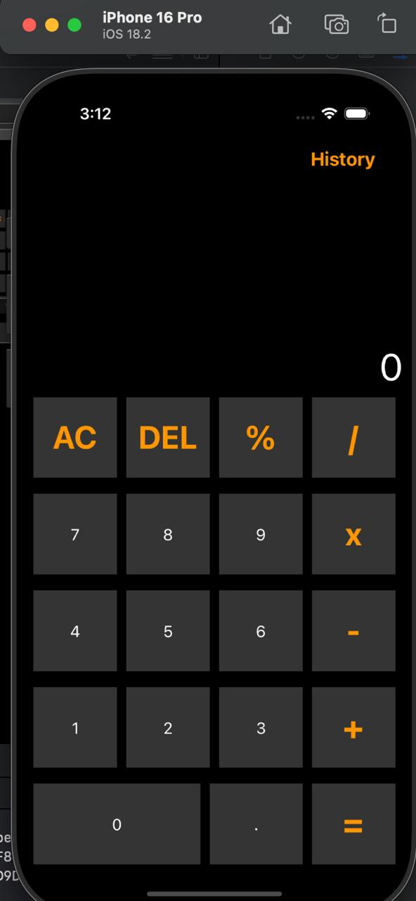

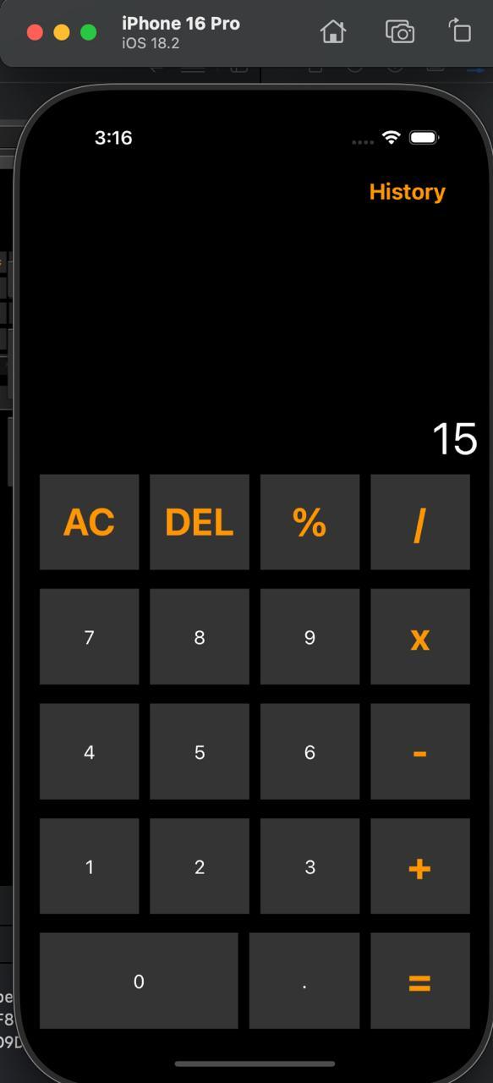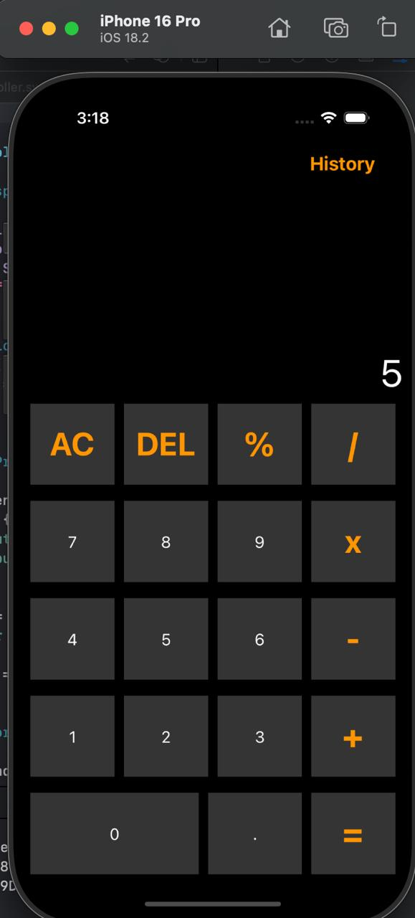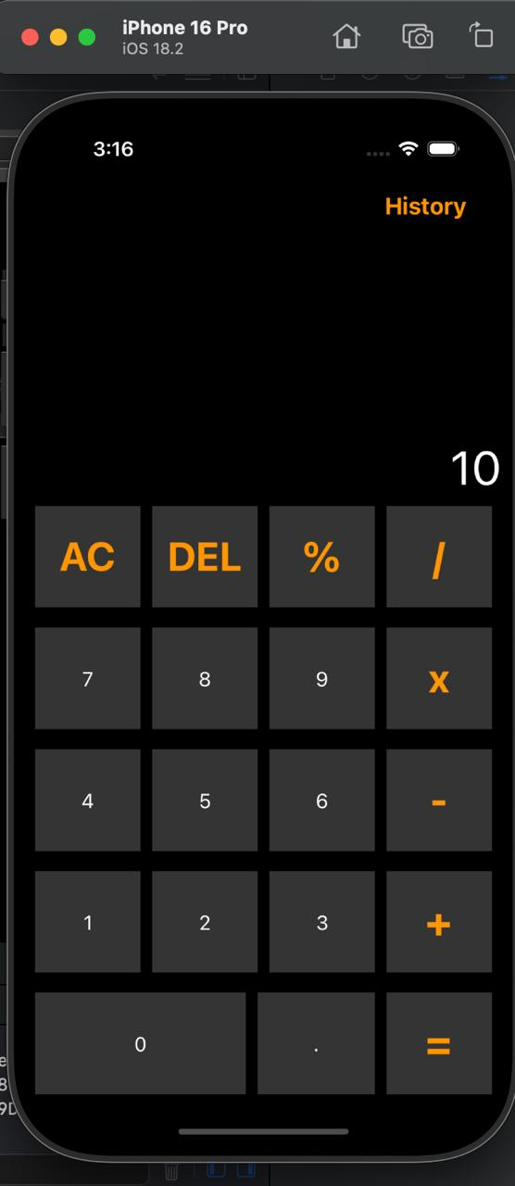**Addition:**

**Subtraction:**

**Multiplication:**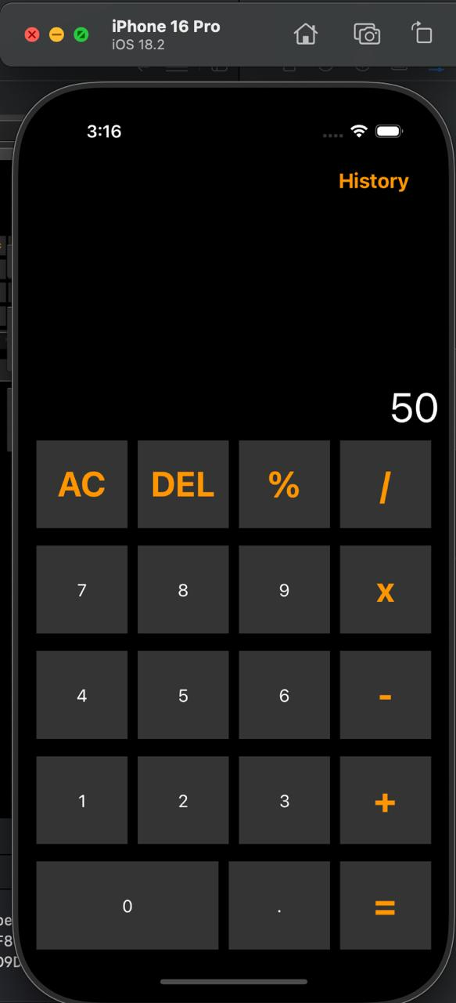

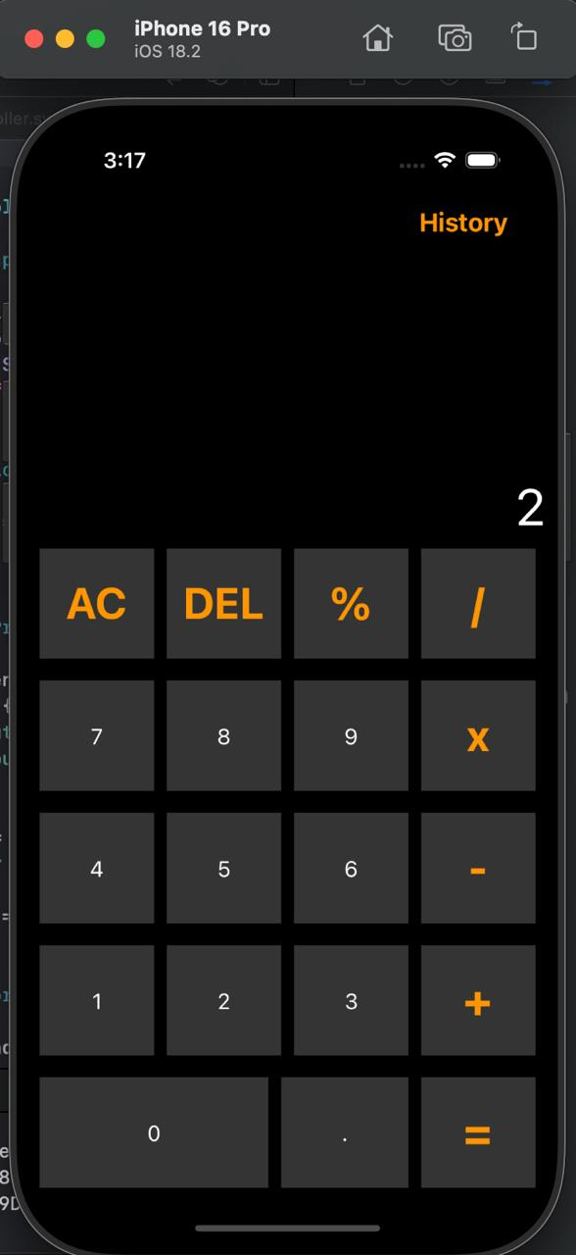**Division:**

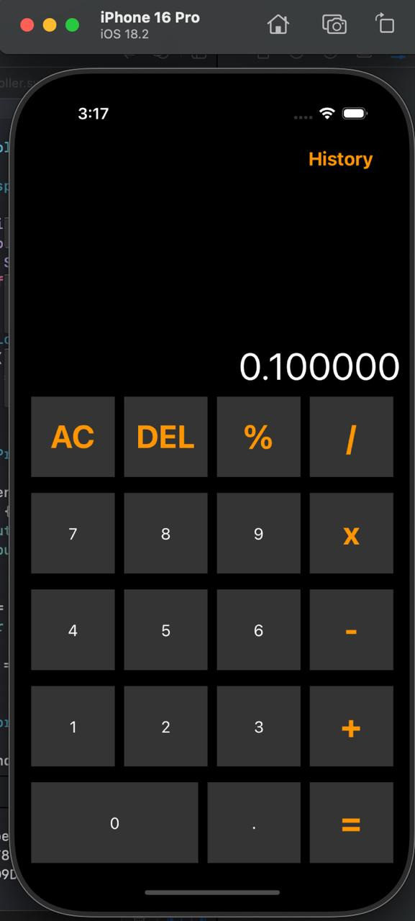**Percentage:**

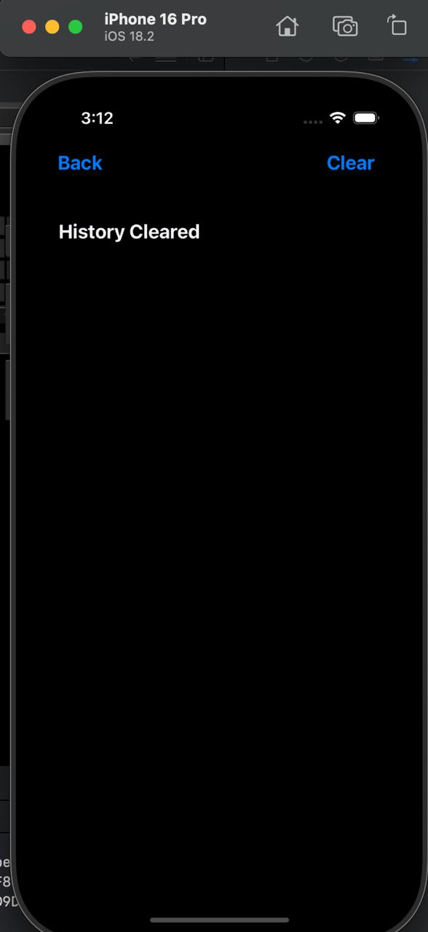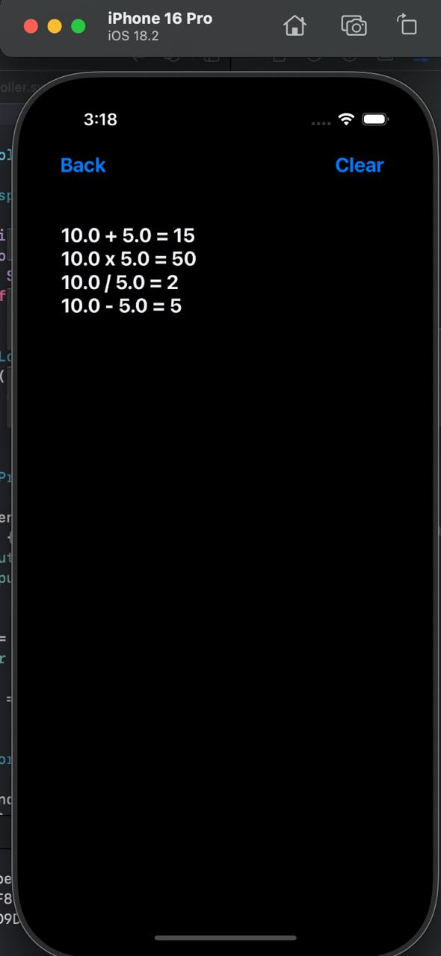**History:**

**DAILY DIARY**

**DAY 1**

**Date:** 16th Dec 2024  
 **Remarks:** Started with the **Swift programming language**, covering the basics such as syntax, data types, variables, constants, loops, and conditionals. Understood how Swift differs from other programming languages.

**Dept./Division:** Mobile App Development  
 **Key Highlights of the Day:**

* Introduction to Swift
* Variables, constants, and data types
* Control flow (loops, conditionals)
* Hands-on coding exercises

**DAY 2**

**Date:** 17th Dec 2024  
 **Remarks:** Covered **functions and closures** in Swift. Understood function parameters, return types, and the importance of closures for asynchronous programming.

**Key Highlights of the Day:**

* Functions in Swift (parameters, return types)
* Closures and their usage
* Error handling with try, catch, and throw

**DAY 3**

**Date:** 18th Dec 2024  
 **Remarks:** Explored **Object-Oriented Programming (OOP)** in Swift, including **structs, classes, inheritance, and protocols**.

**Key Highlights of the Day:**

* Difference between structs and classes
* Implementing inheritance and method overriding
* Understanding protocols and protocol-oriented programming

**Assignments Given:**

* **Assignment No 2:** iOS Structures

**DAY 4**

**Date:** 19th Dec 2024  
 **Remarks:** Introduction to **UIKit** and its role in developing iOS applications. Understood how to build user interfaces using UIKit components such as buttons, labels, text fields, and images.

**Key Highlights of the Day:**

* Introduction to UIKit
* Understanding views, buttons, labels, and text fields
* Connecting UI elements to code using IBOutlet and IBAction
* Understanding UIViewController and its lifecycle

**DAY 5**

**Date:** 20th Dec 2024  
 **Remarks:** Focused on designing app interfaces using **Storyboards** and **View Controllers**. Learned how to add multiple screens, configure navigation, and set up relationships between different views.

**Key Highlights of the Day:**

* Storyboards and their significance
* View Controllers and their role in iOS apps
* Designing interfaces using Interface Builder
* Creating multiple screens and linking them

**DAY 6**

**Date:** 23rd Dec 2024  
 **Remarks:** Started learning **Auto Layout and Stack Views**, which are essential for designing responsive user interfaces that adjust dynamically based on screen sizes.

**Key Highlights of the Day:**

* Auto Layout and constraints
* Stack Views for organizing UI elements
* Responsive UI design best practices

**DAY 7**

**Date:** 24th Dec 2024  
 **Remarks:** Practiced advanced **Auto Layout** techniques, including dynamically updating constraints. Created a small sample app that adjusts layouts dynamically based on screen size changes.

**Assignments Given:**

* **Assignment No 3:** iOS Functions

**Key Highlights of the Day:**

* Advanced Auto Layout
* Dynamically updating constraints

**DAY 8**

**Date:** 26th Dec 2024  
 **Remarks:** Explored **Segue**, which is used for transitioning between screens in an iOS app. Learned how to pass data between screens using the prepare(for:sender:) method.

**Key Highlights of the Day:**

* Introduction to Segue
* Passing data between view controllers
* Hands-on navigation implementation

**DAY 9**

**Date:** 27th Dec 2024  
 **Remarks:** Studied **Tab Bar Controllers**, which help in creating multi-screen applications. Implemented a tab-based app where each tab represented a different section.

**Key Highlights of the Day:**

* Implementing Tab Bar Controllers
* Managing multiple screens efficiently

**DAY 10**

**Date:** 30th Dec 2024  
 **Remarks:** Worked on **Optionals and Enumerables** in Swift. Understood the concept of optional variables, how to safely unwrap them, and the importance of enumerations in Swift programming.

**Assignments Given:**

* **Assignment No 4:** iOS Optionals and Enumerations

**Key Highlights of the Day:**

* Understanding Optionals and their safe unwrapping (if let, guard let)
* Working with Enums in Swift

**DAY 11**

**Date:** 31st Dec 2024  
 **Remarks:** Revisited **Segue & Navigation Controller**. Created an app with multiple screens using navigation controllers and practiced handling screen transitions programmatically.

**Key Highlights of the Day:**

* Implementing Navigation Controllers
* Managing hierarchical navigation
* Programmatic segue and transitions

**Assignments Submission Deadline: 31st Jan 2025**

All assignments were required to be submitted by **31st January 2025**.

**Project Assigned on 7th February 2025**

**Simple Calculator App with History**  
On 7th February 2025, I was assigned the Simple Calculator App with History project. The objective was to build an iOS application that performs basic arithmetic operations and maintains a history of all calculations performed by the user.

**Project Features:**

1. Users can perform basic operations: addition, subtraction, multiplication, and division.
2. Each calculation is appended to a local history file.
3. Users can view past calculations in a History View.
4. A Clear History option is provided to delete stored data.
5. The app includes a simple and user-friendly interface with multiple screens: ○ Calculator View: Interface with number and operation buttons.

**Technologies Used:**

* **Swift & UIKit** for UI and logic implementation.
* **Auto Layout & Stack Views** for responsive design.
* **UserDefaults/FileManager** for local storage.
* **Navigation Controller & Tab Bar Controller** for screen transitions.
* **References**

1. **Apple Developer Documentation** – Official documentation for Swift, UIKit, Auto Layout, and other iOS development frameworks.
   * <https://developer.apple.com/documentation/>
2. **Swift Language Guide** – Comprehensive guide on Swift programming, covering syntax, functions, OOP, and optionals.
   * <https://developer.apple.com/swift/resources/>
3. **Hacking with Swift** – Online tutorials and learning resources for Swift and iOS development.
   * <https://www.hackingwithswift.com/>
4. **Raywenderlich iOS Tutorials** – Practical tutorials covering Swift, UI design, and app development.
   * https://www.raywenderlich.com/ios
5. **Stack Overflow & Developer Forums** – Used for troubleshooting errors and finding solutions to technical problems.
   * <https://stackoverflow.com/>
6. **Xcode & Interface Builder User Guide** – Reference for using Xcode, debugging, and building UI with Interface Builder.
   * <https://developer.apple.com/xcode/>
7. **iOS Human Interface Guidelines** – Best practices for UI/UX design in iOS applications.

* <https://developer.apple.com/design/human-interface-guidelines>

|  |  |  |
| --- | --- | --- |
| **Miss. Aprupa S. Pawar** | **Mrs. Leena V. Patil** | **Dr. Medha A. Shah** |
| Guide | Project Coordinator | Head |

Department of Computer Science and Engineering

**Walchand College Of engineering, Sangli**

**WALCHAND COLLEGE OF ENGINEERING, SANGLI**

**Industrial Supervisor/Guide/Mentor Evaluation**

**Part I: Contact Information Student**

Name: Student ID# Class Year:

Campus Address:

City, State:

Phone: Email:

# Industrial Supervisor

Name:

Title:

Company/Organization:

Internship Address:

City, State, Pin:

Phone:

Email:

# Faculty Mentor

Name: Phone:

Campus Address:

# Academic Credit Information

Internship Title: Department:

Course #: Credits:

Grading Option:

Beginning Date: Ending Date:

Hours per Week: Internship is:

Paid Unpaid

# Evaluation to be carried out by Mentor/Guide/Internship Supervisor

You are requested to evaluate the student’s performance on the basis of grading i.e. Excellent, Very Good, Satisfactory and Non-Satisfactory on the below mentioned factors.

|  |  |
| --- | --- |
| Name of Students | Evaluation Ranking |
| a Attendance and general behavior |  |
| b Relation with workers and supervisors |  |
| c Initiative and efforts in learning |  |
| d Knowledge and skills improvement |  |
| e Contribution to the organization |  |

Each student is required to prepare Internship diary and report.

# Please evaluate your intern by indicating the frequency with which you observed the following behaviors:

|  |  |  |  |  |
| --- | --- | --- | --- | --- |
| Parameters | Needs improvement | Satisfactory | Good | Excellent |
| Behaviors |  |  |  |  |
| Performs in a dependable manner |  |  |  |  |
| Cooperates with co-workers and  supervisors |  |  |  |  |
| Shows interest in work |  |  |  |  |
| Learns quickly |  |  |  |  |
| Shows initiative |  |  |  |  |
| Produces high quality work |  |  |  |  |
| Accepts responsibility |  |  |  |  |
| Accepts criticism |  |  |  |  |
| Demonstrates organizational skills |  |  |  |  |
| Uses technical knowledge and  expertise |  |  |  |  |
| Shows good judgment |  |  |  |  |
| Demonstrates creativity/originality |  |  |  |  |
| Analyzes problems effectively |  |  |  |  |
| Is self-reliant |  |  |  |  |
| Communicates well |  |  |  |  |
| Writes effectively |  |  |  |  |
| Has a professional attitude |  |  |  |  |
| Gives a professional appearance |  |  |  |  |
| Is punctual |  |  |  |  |
| Uses time effectively |  |  |  |  |

Overall performance of student intern (circle one):

(Needs improvement/ Satisfactory/ Good/

Excellent) Additional comments, if any:

Name and Signature of Industry

Supervisor/Guide/Mentor